Week 5. Electrical hazards

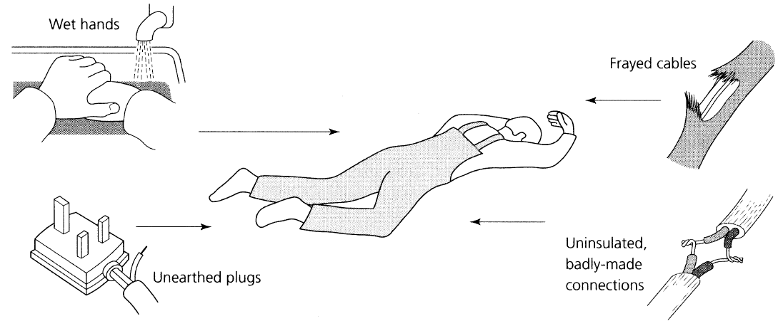
The most common causes of electrical shock are shown in Fig. 1. The installation and maintenance of electrical equipment must be carried out only by a fully trained and registered electrician. The installation and equipment must conform to international standards and regulations as laid down in safety legislation and the codes of practice and regulations published by the Institution of Electrical Engineers (IEE).

Figure 1. Causes of electric shock
An electric shock from a 240 volt single-phase electric power supply (lighting and office equipment) or a 415 volt three-phase supply (most factory machines) can easily kill you. Even if the shock is not sufficiently severe to cause death, it can still cause serious injury. The sudden convulsion caused by the shock can throw you from a ladder or against moving machinery. To reduce the risk of shock, all electrical equipment should be earthed or double insulated. Further, portable power tools should be fed from a low-voltage transformer at 110 volts. The power tool must be suitable for operating at such a voltage. The transformer itself should be protected by a circuit breaker containing a residual current detector. The fuses and circuit breakers designed to protect the supply circuitry to the transformer react too slowly to protect the user from electric shock.
The electrical supply to a portable power tool should, therefore, be protected by a residual current detector (RCD). Such a device compares the magnitudes of the current flowing in the live and neutral conductors supplying the tool. Any leakage to earth through the body of the user or by any other route will upset the balance between these two currents. This results in the supply being immediately disconnected. The sensitivity of residual current detectors is such that a difference of only a few milliamperes is sufficient to cut off the supply and the time delay is only a few microseconds. Such a small current applied for such a short time is not dangerous.
In the event of rendering first aid to the victim of electrical shock, great care must be taken when pulling the victim clear of the fault which caused the shock. The victim can act as a conductor and thus, in turn, electrocute the rescuer. If the supply cannot be quickly and completely disconnected, always pull the victim clear by his or her clothing which, if dry, will act as an insulator. If in doubt, hold the victim with a plastic bag or cloth known to be dry. Never touch the victim’s bare flesh until the victim is clear of the electrical fault. Artificial respiration must be started immediately after the victim has been pulled clear of the fault or the live conductor.

Task 1 Match the words to their translation

a) verbs

- to earth | - подвергнуть воздействию электрическим током
- to insulate | - заземлить
- to feed | - подключить к источнику питания
- to upset the balance | - оказать первую помощь
- to render first aid | - освобождать
- to pull clear | - нарушить равновесие
- to electrocute | - изолировать

b) nouns (electricity)

- circuit breaker | - плавкий предохранитель
- residual current | - остаточный ток
- fuse | - проводник
- circuitry | - электрическая схема
- insulator | - источник питания
- conductor | - электрическое напряжение
- live conductor | - провод под напряжением
- voltage | - изолятор
- current | - прерыватель цепи
- sensitivity | - чувствительность
- supply | - электрический ток

с) nouns (hazards)

- electric shock | - электроинструмент
- fault | - поражение электрическим током
- electrical fault | - неисправность, короткое замыкание
- power tools | - повреждение в электрической цепи

Task 2. List the common causes of electric shock
Task 3. Write the instructions for rendering first aid to the victim of electrical shock . Use imperatives.
Model:
…great care must be taken when pulling the victim clear of the fault which caused the shock. - Take care of yourself when pulling the victim clear of the fault which caused the shock.

